

**UNIVERSITI MALAYSIA TERENGGANU**

___________________________________________________________

**CSM 3023 WEB BASED APPLICATION DEVELOPMENT (K1)**

**LAB REPORT 1**

**SEMESTER II 2023/2024 _________________________________________________**

**Prepared for:**

DR. MOHAMAD NOR BIN HASSAN

SIR MOHD ARIZAL SHAMSUL BIN MAT RIFIN

**Prepared by:**

SAKINAH BINTI JUSOH (S65380)

**Task 5**: Linking Netbeans to Apache Tomcat and Writing a Simple Java Servlet

Objective: Link Netbeans to Apache Tomcat and Writing a Simple Java Servlet

Problem description: To write simple Java Servlet

**Source code**

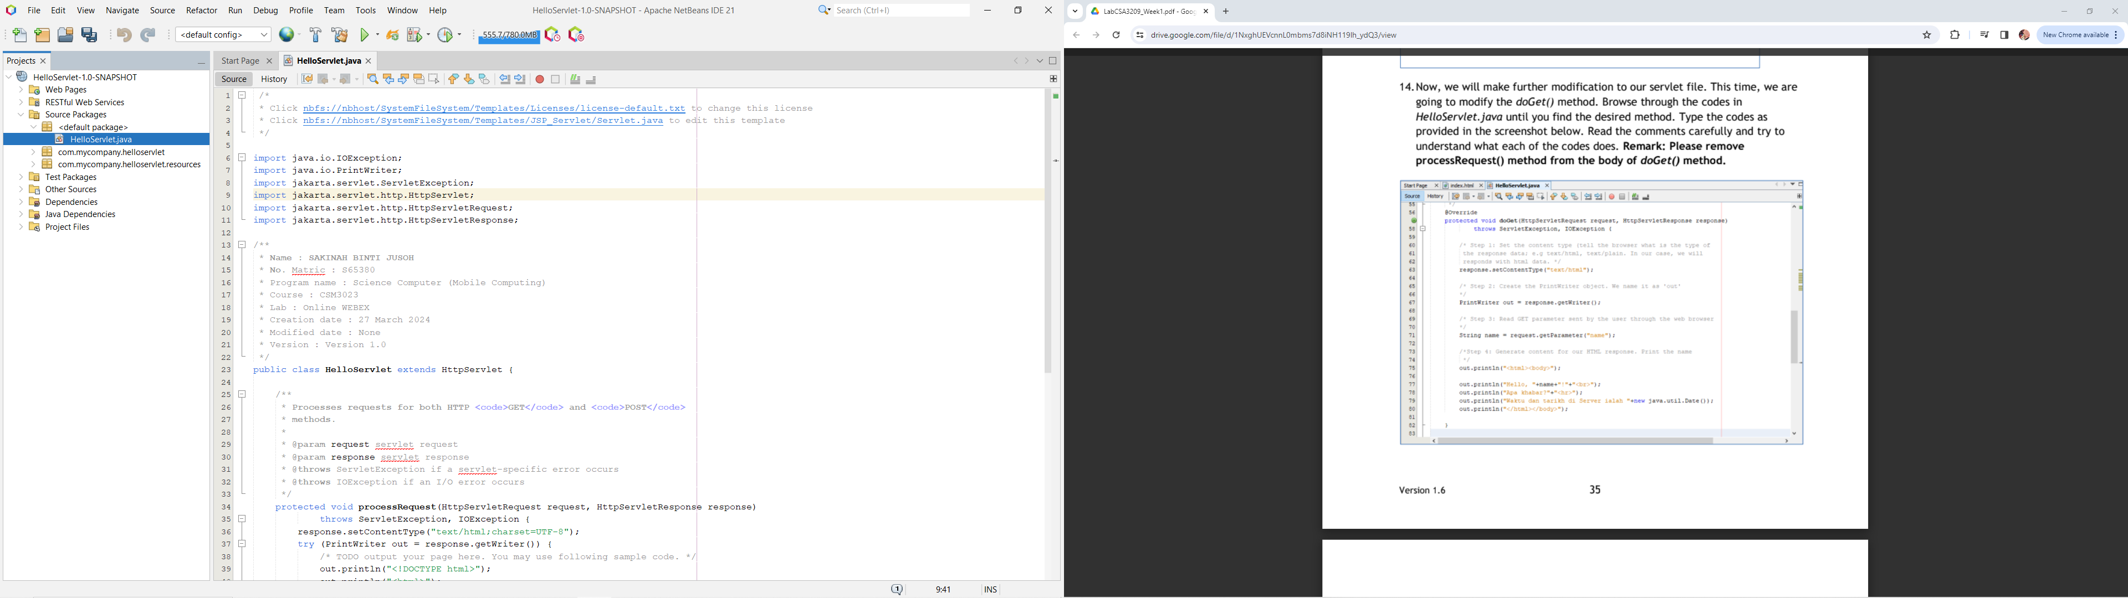

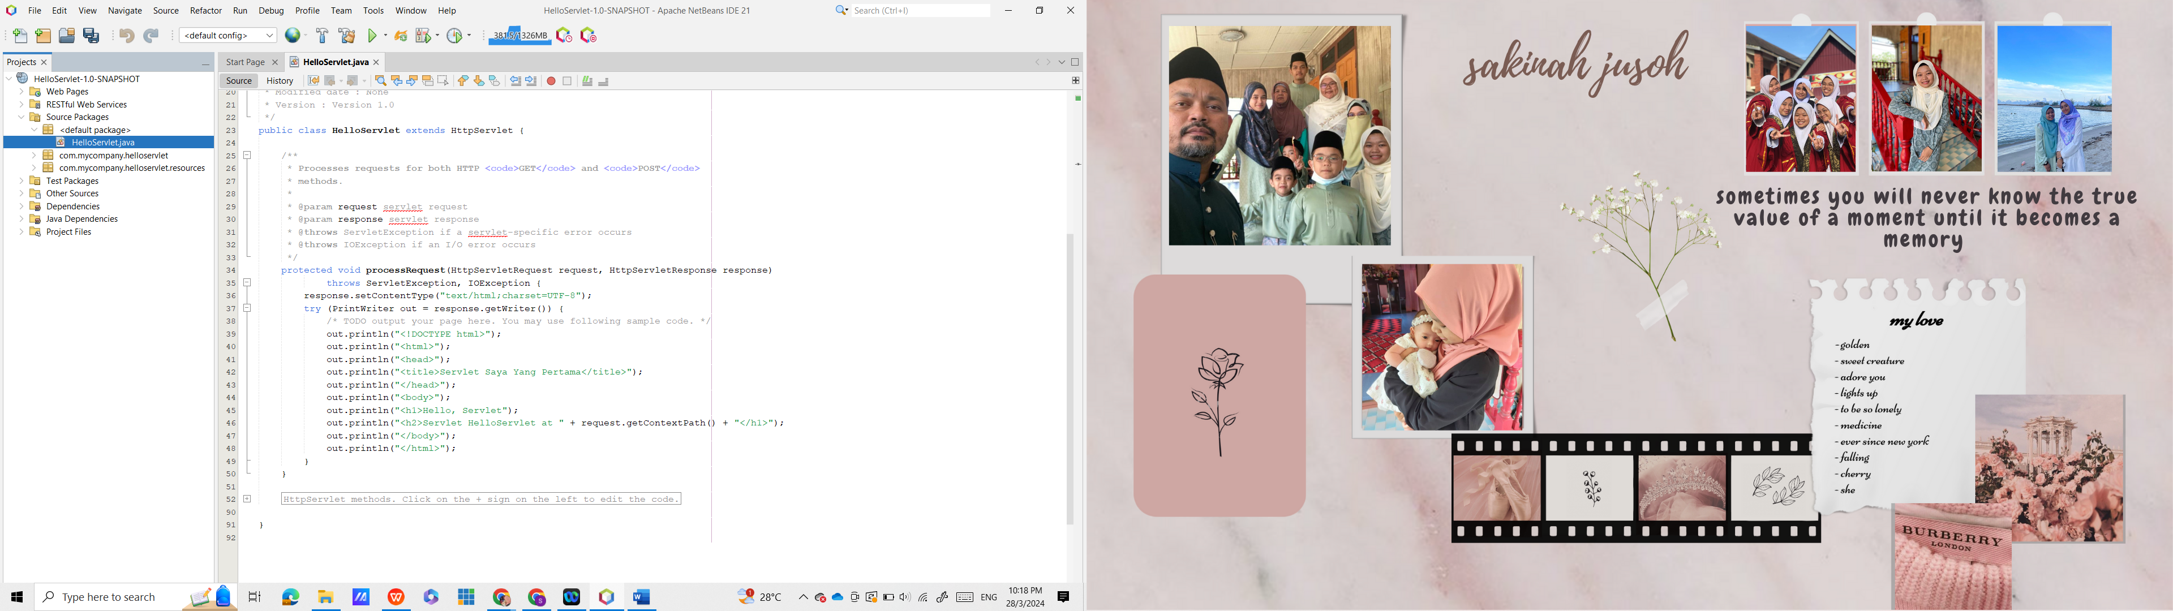

**Output**

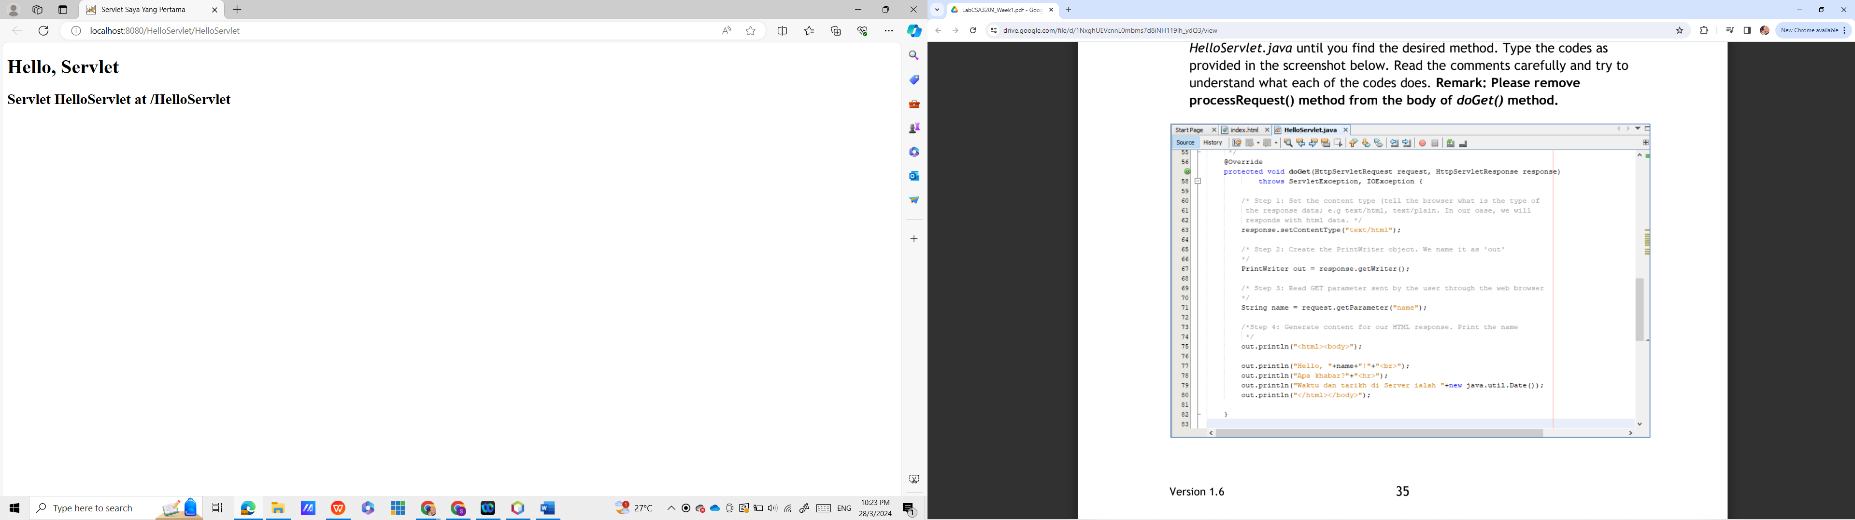

**Source code**

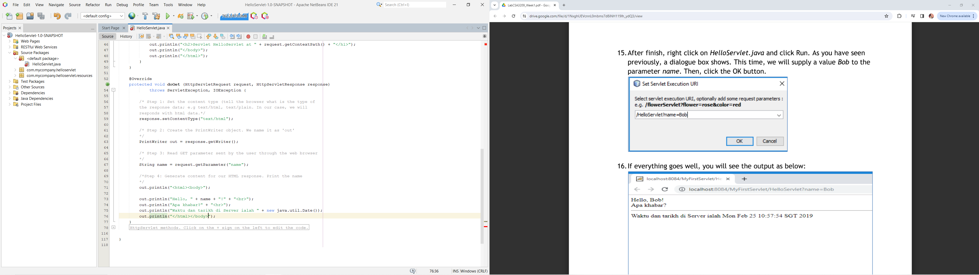

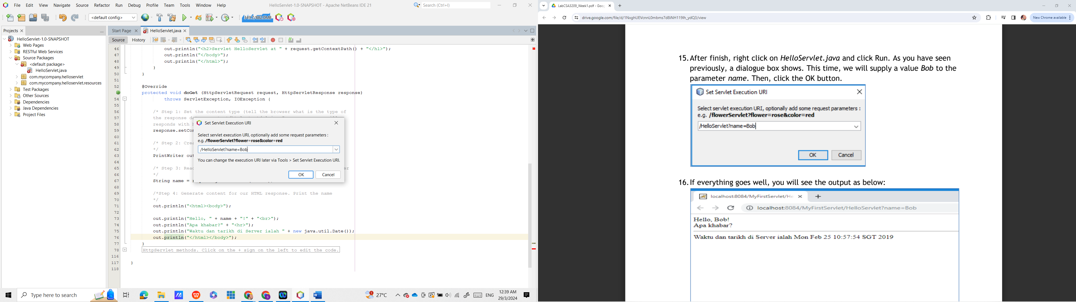

**Output**

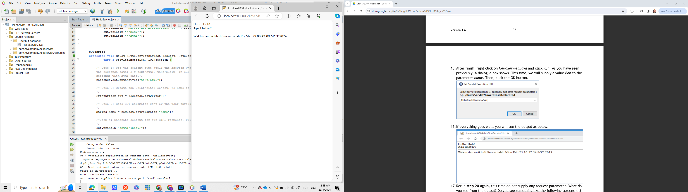

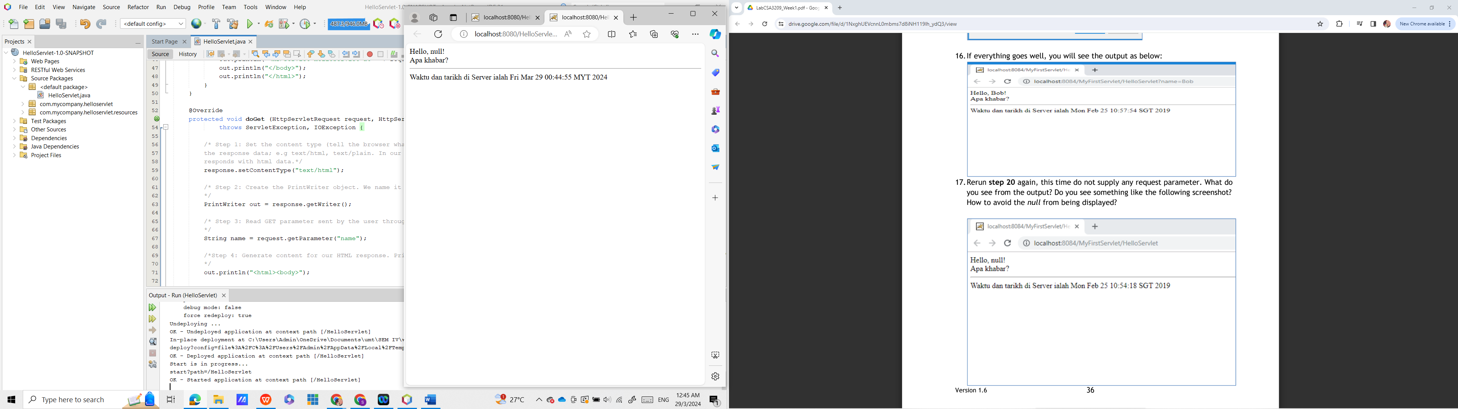

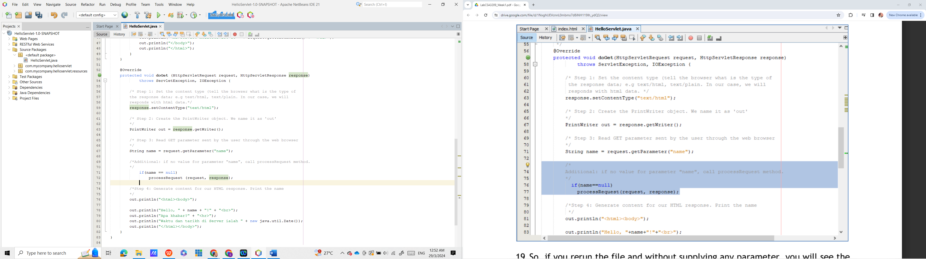

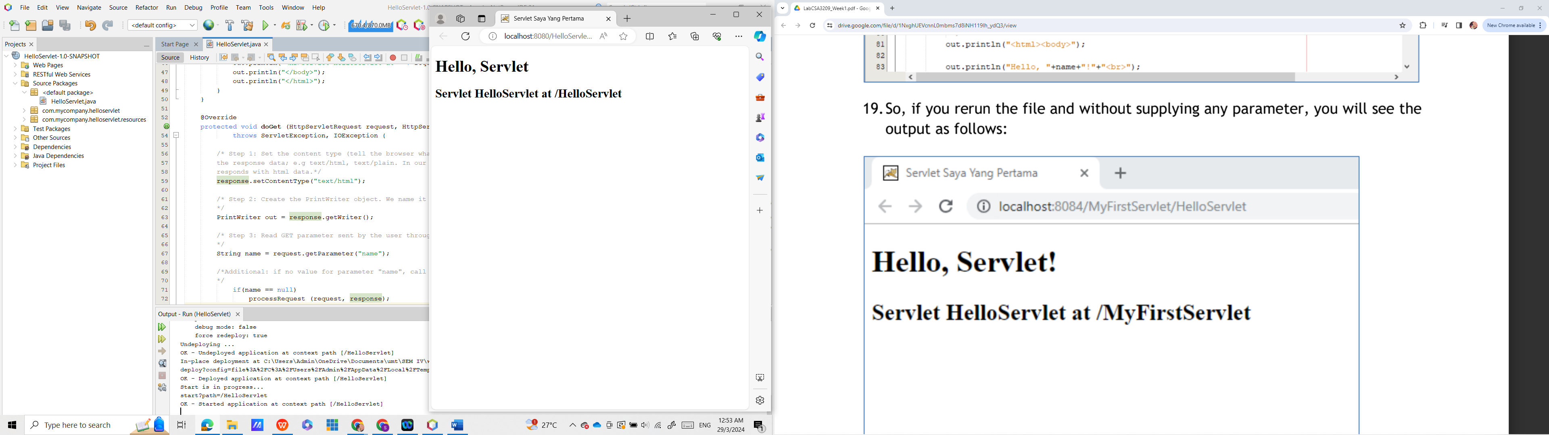

**Task 6**: Writing a simple JSP Program

Objective: Writing a simple plain JSP Program

Problem description: Write a simple plain JSP Program to display “Welcome to [MATRICNUMBER]..!

**Source code**

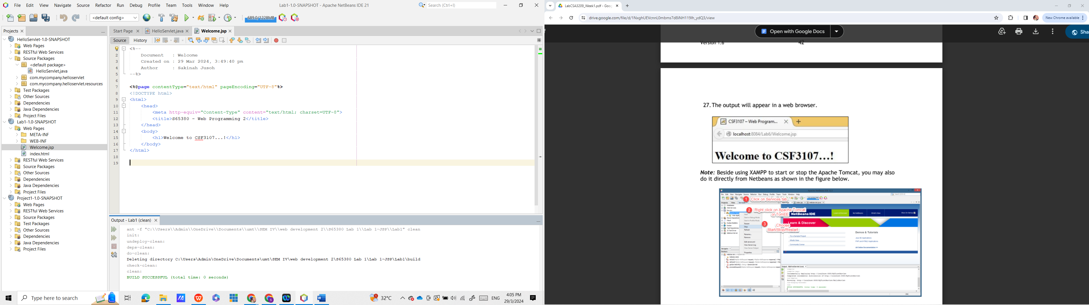

**Output**

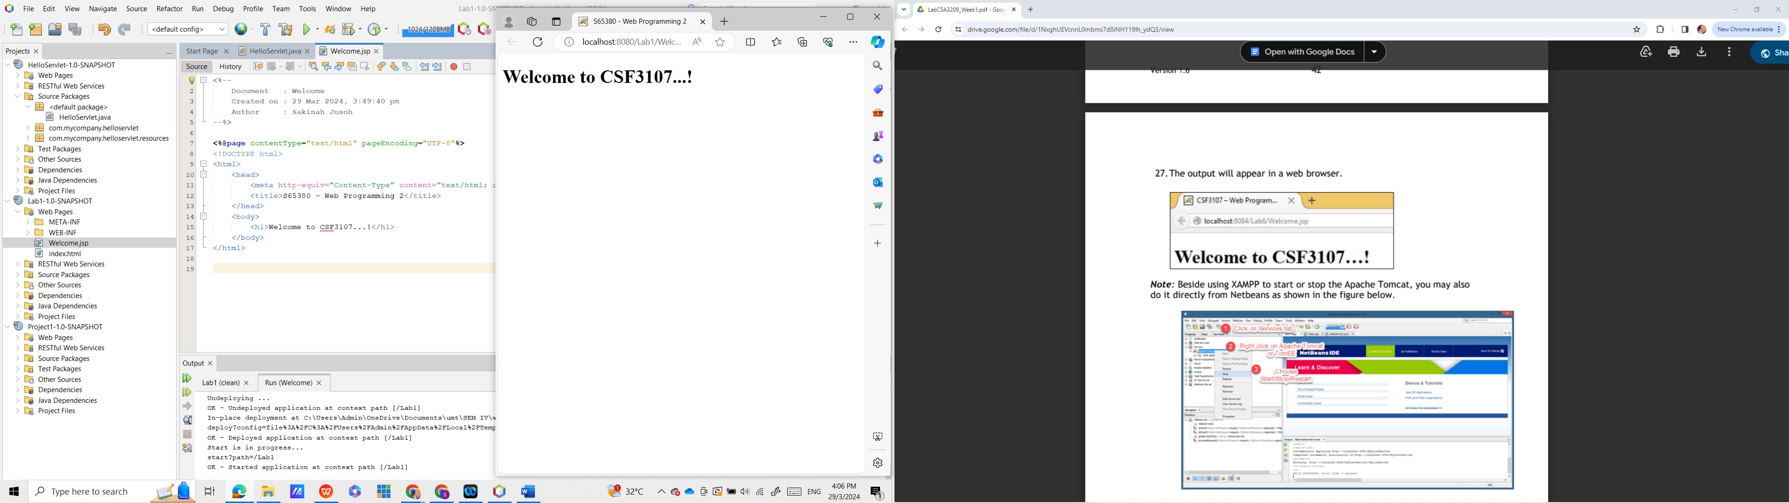

Reflection

1. What have you learned from this exercise?

**I have learnt about how to create and run JSP file in NetBeans IDE.**

1. Explain the general concept of how the JSP’s file work?

**A JSP container works with the web server to provide the runtime environment and other services a JSP needs.**

1. Based on your observation of the previous tasks (Task 3 and Task 4), what are the different you can find between servlet and JSP?

**JSP is easier to code than servlet.**

**Task 7:** Use Java Reference Datatype/Class Wrapper in JSP

Objective: Using Java’s object in JSP page.

Problem: Display the current date, perform auto refresh header in JSP’s page

**Source code**

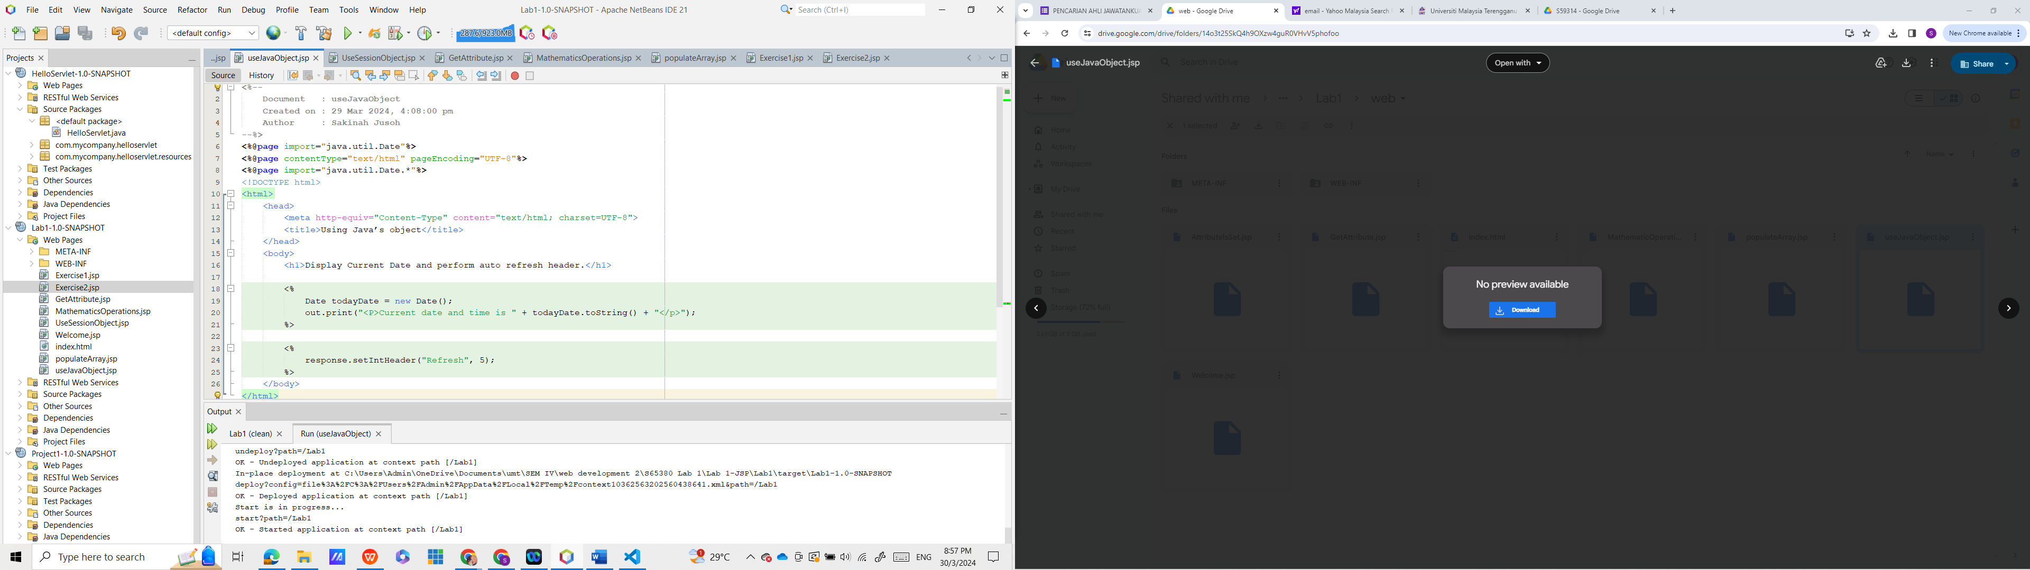

**output**

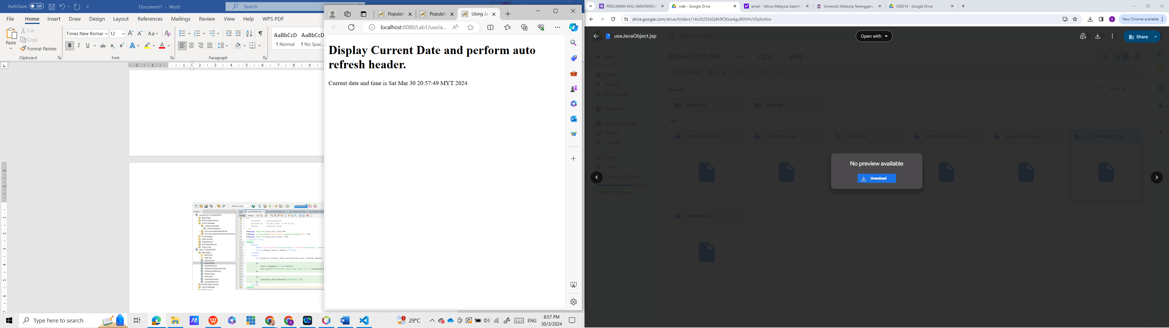

Reflection

1. What have you learnt from this exercise?

**I have learnt about how to call method date.**

1. What is Java Scriplet?

**A scriplet is a piece of software code that is used by a native web page scripting language to perform a specific function or process. Scriplets are primarily implemented in JavaServer Pages (JSP) and include variables, expressions or statements that are used only when requested by a certain client or process.**

1. How to use Java code in your JSP’s page?

**Use tags and put the Java code in between the tags.**

**Task 8:** Using JSP Implicit object in JSP page.

Objective: Using JSP Implicit object (session) in JSP page.

Problem description: Using Session object, perform simple Mathematics operations in JSP’s page.

**Source code**

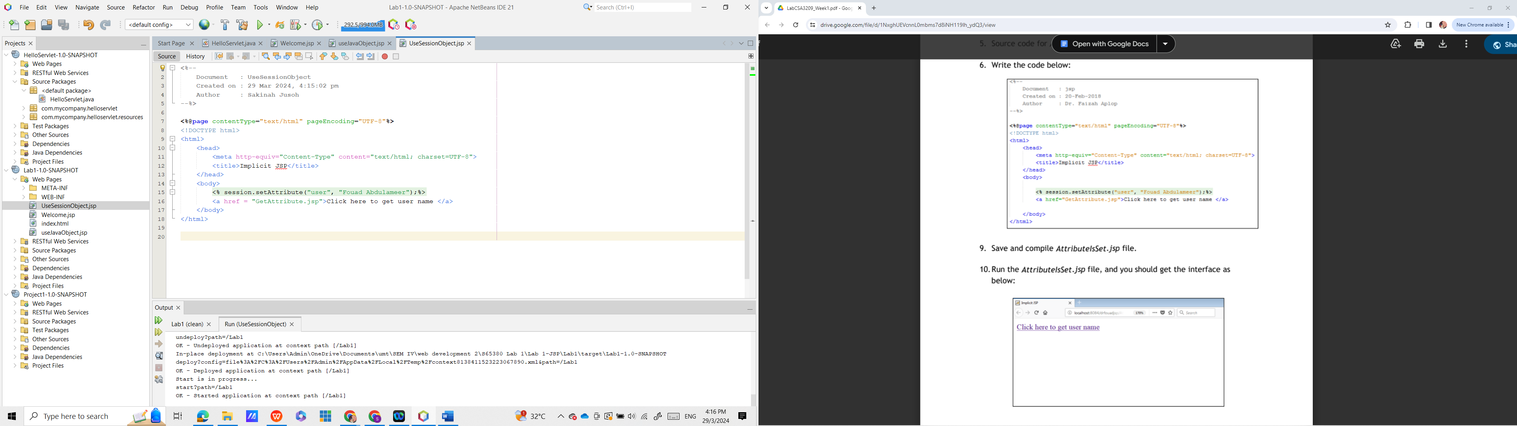

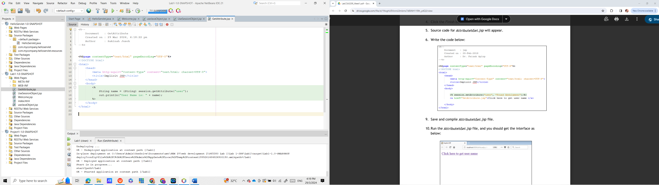

**Output**

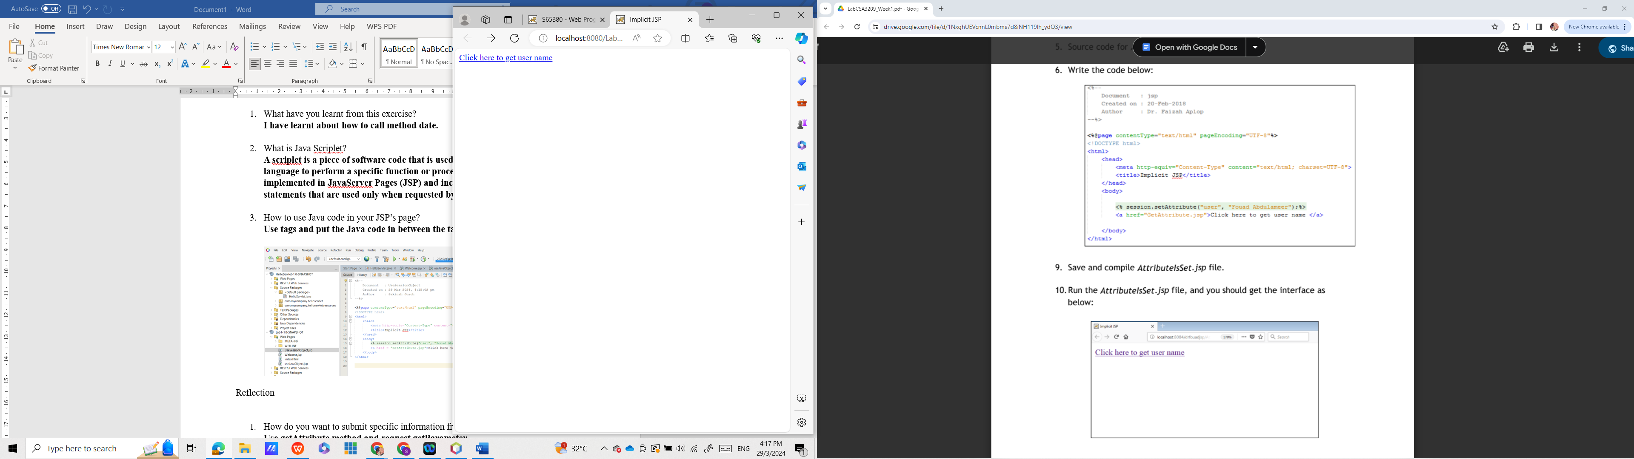

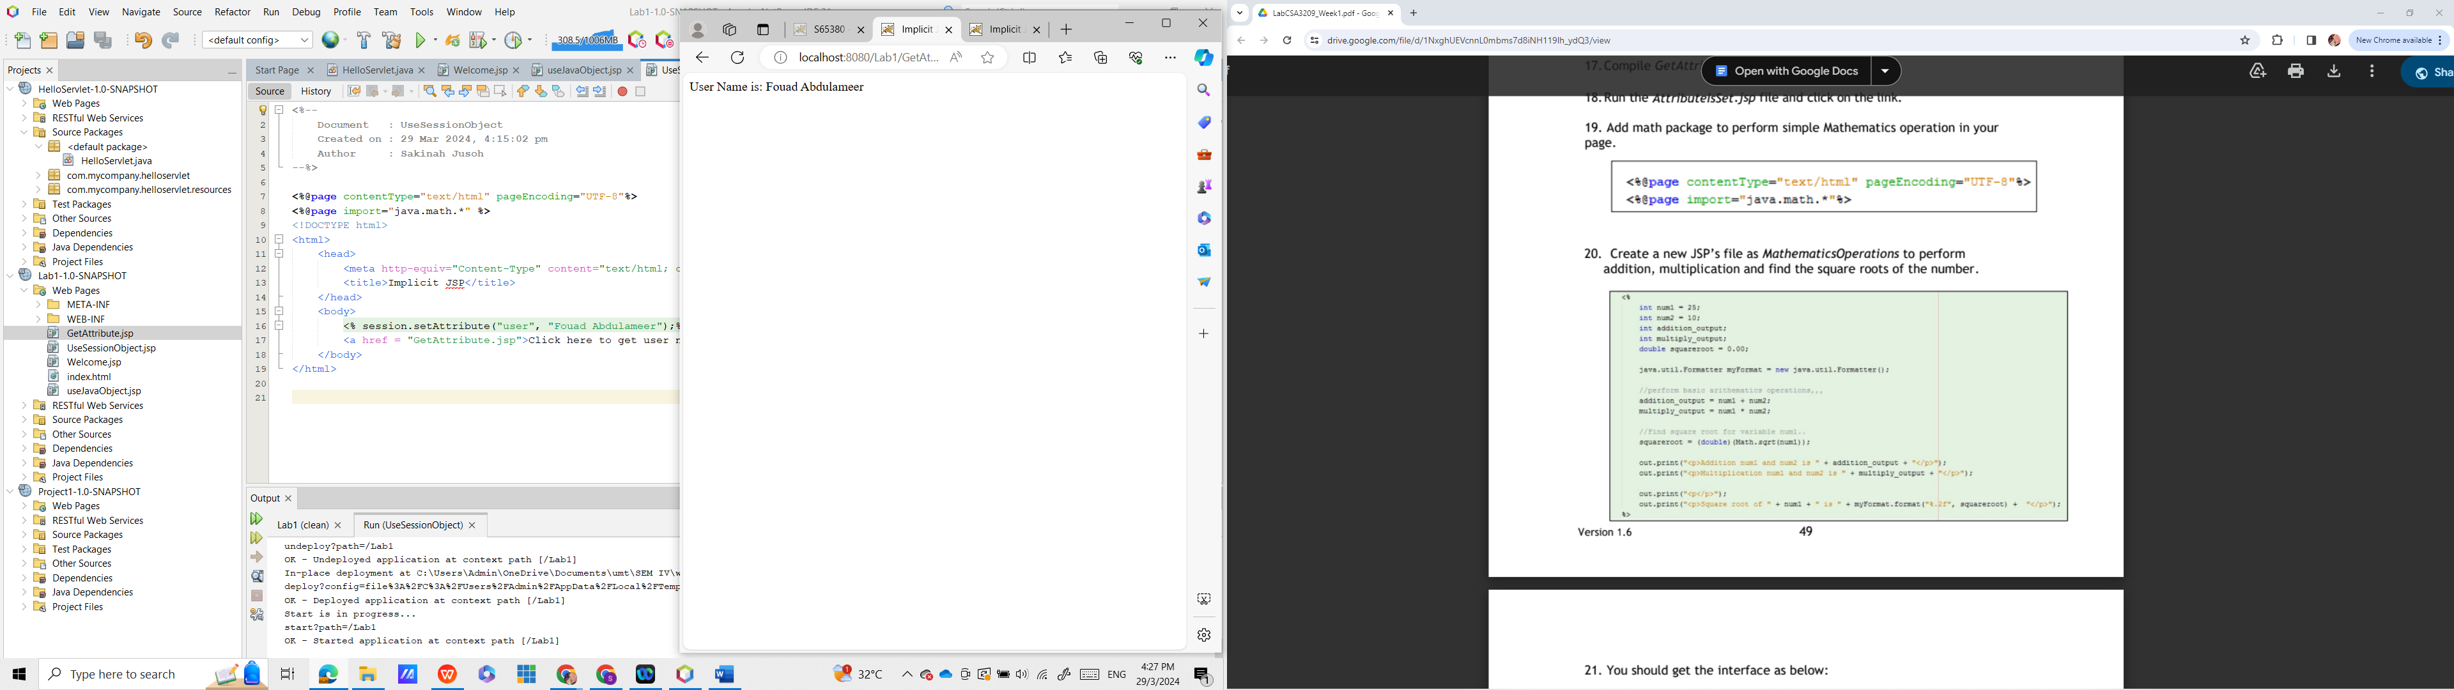

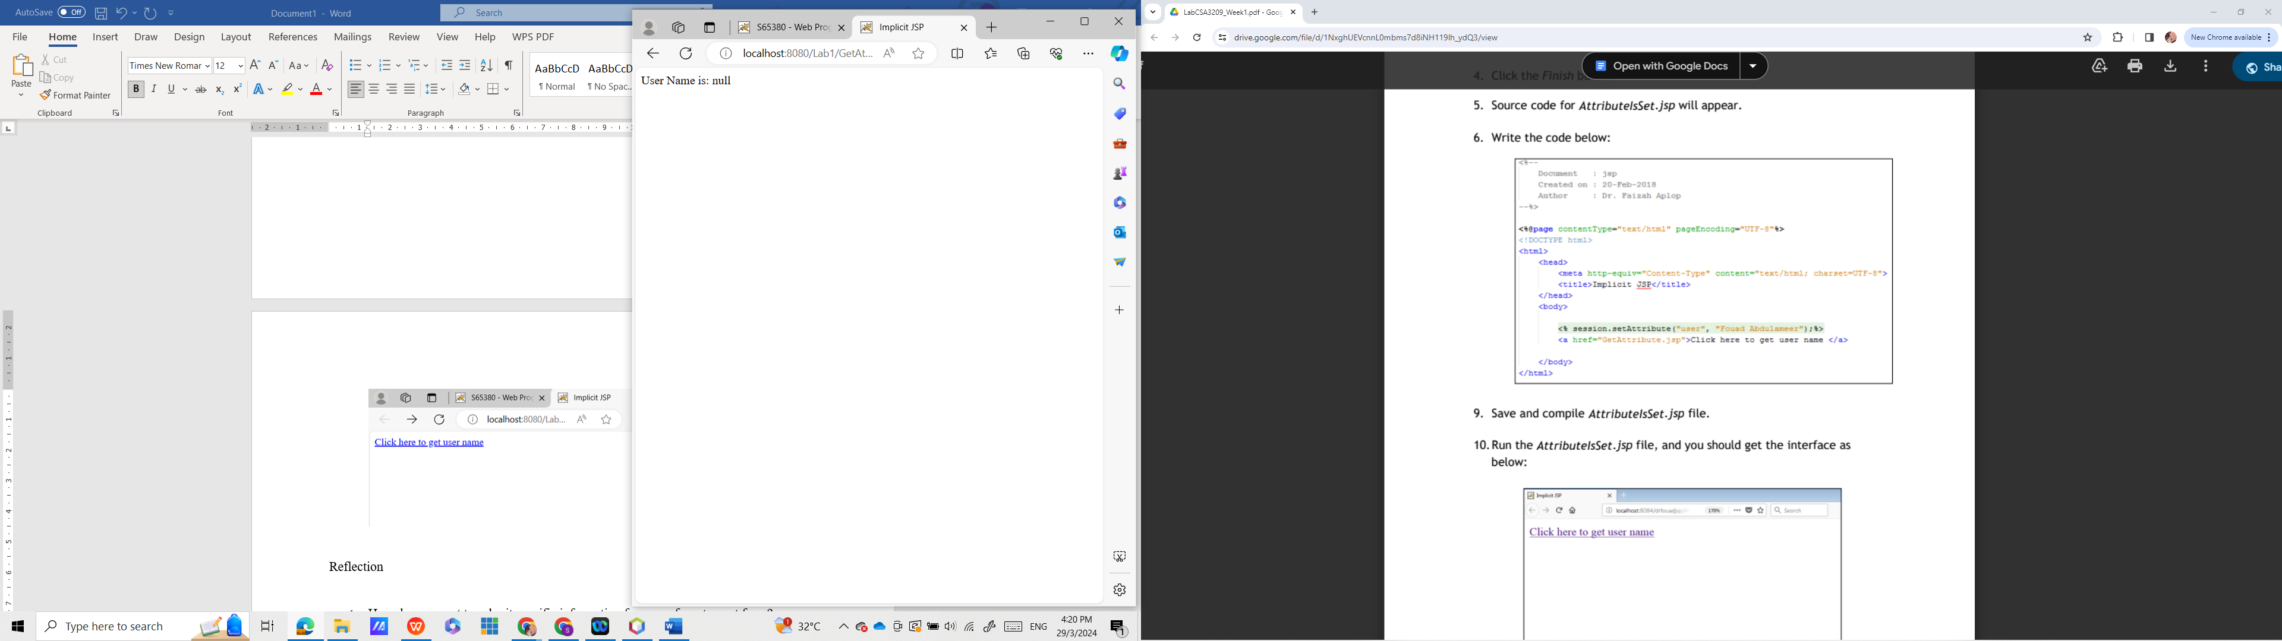

**Source code**

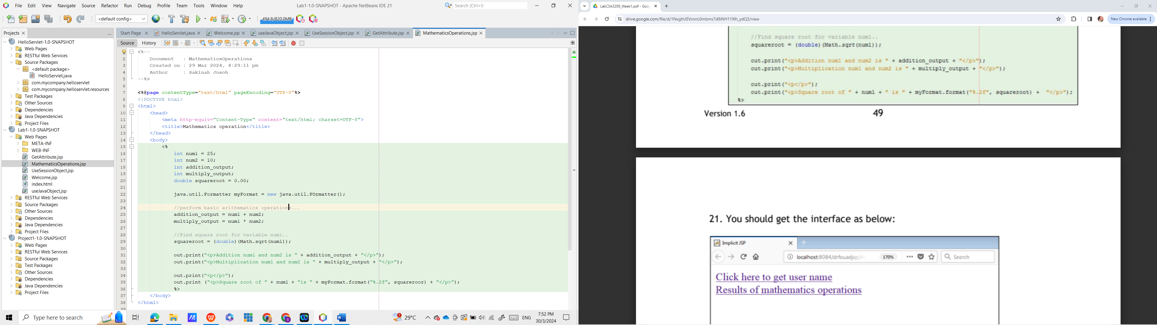

**Output**

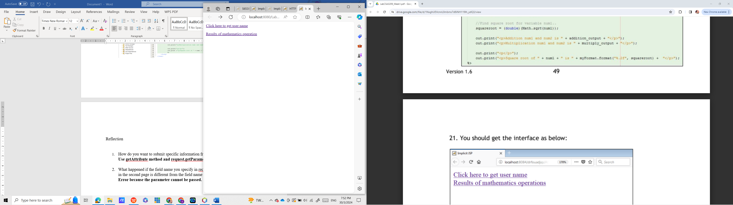

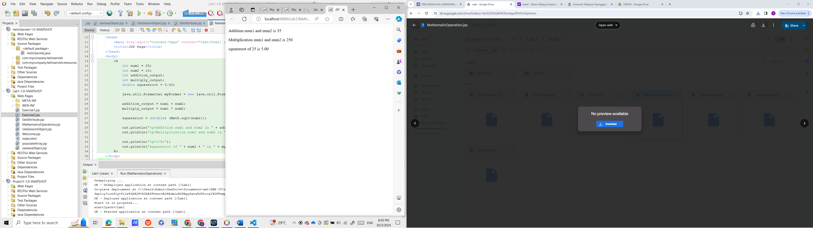

Reflection

1. How do you want to submit specific information from one form to next form?

**Use getAttribute method and request.getParameter.**

1. What happened if the field name you specify in request.getParameter (“field_name”) in the second page is different from the field name you defined in the first page?

**Error because the parameter cannot be passed.**

**Task 9:** Populate array values into HTML’s Table

Objective: Read Java array and populate it into HTML’s Table

Problem description: i. Create a 2D array that store sales data

ii. Then, read an array and populate into HTML’s table.

**Source code**

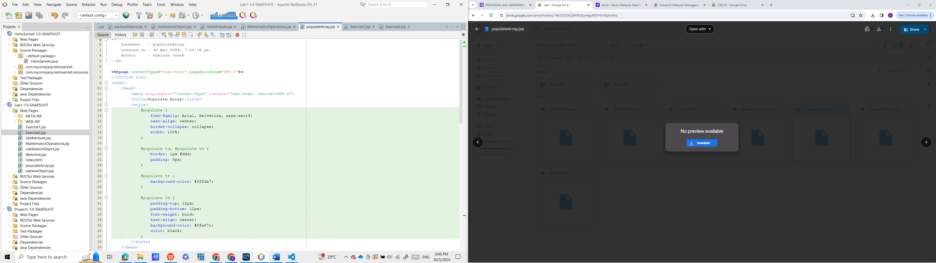

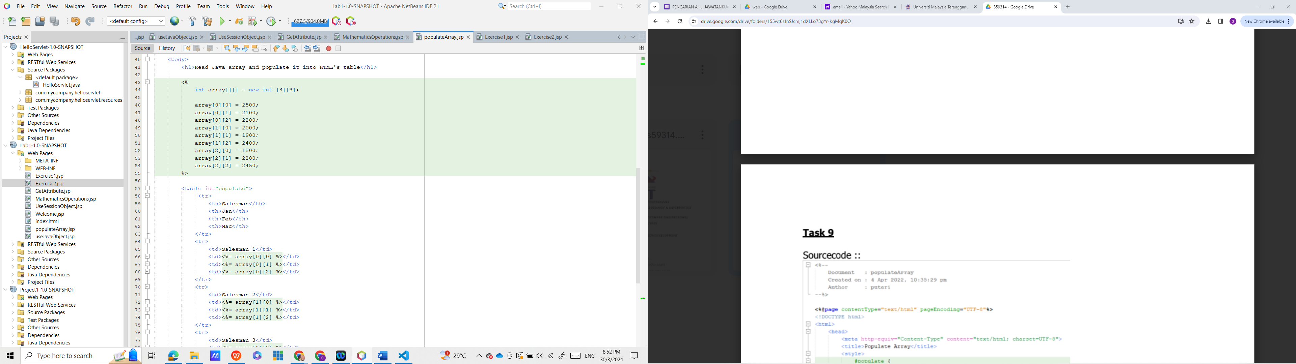

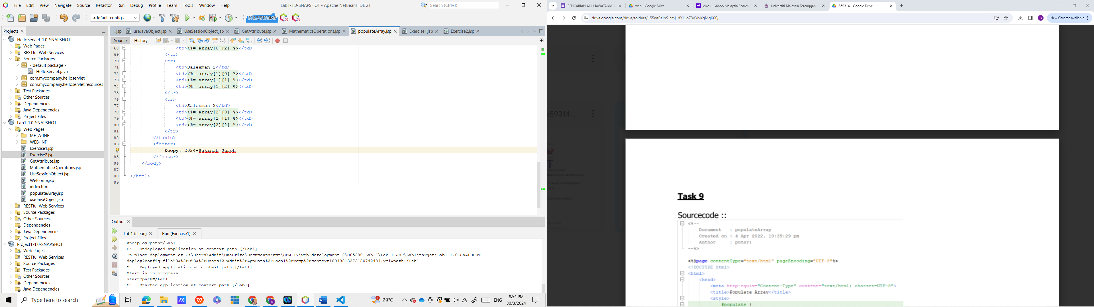

**Output**

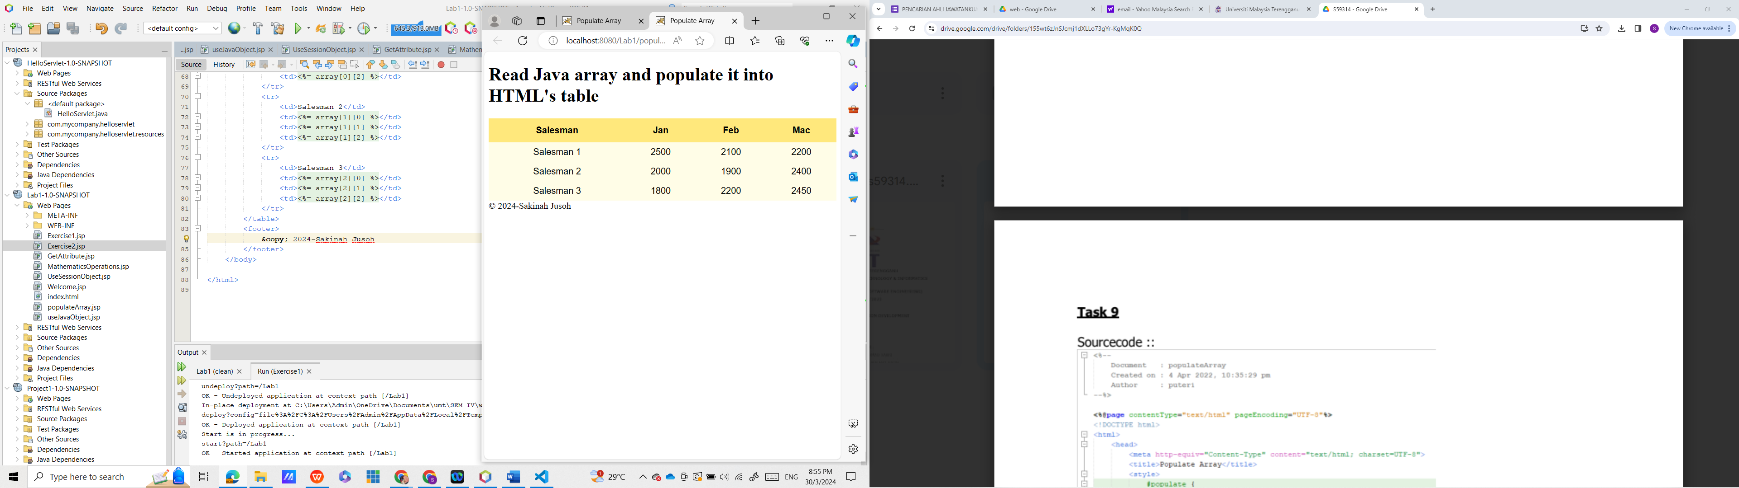

Reflection

1. Write a sample syntax to declare 2D java array.

**int array [] [] = new int [3][3];**

1. Define a sequence of steps on how you accomplish Task 7.
2. **Add the java util package for Date**
3. **Use data type to create Date’s object by code Date todayDate = new Date();. Then use the out.print command to display the date and time.**
4. **Set the refresh and sutoload it in 5 seconds**
5. What is the difference between HTML’s page and JSP’s page?
6. **HTML can only build static web pages but JSP can generate dynamic web pages.**
7. **JSP must communicate with the Web Server, HTML can load faster.**
8. **HTML is a client-side scripting language whereas JSP is a server-side scripting language.**

**Exercise 1**

**Source code**

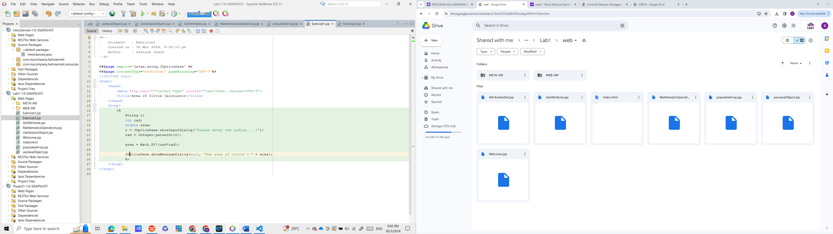

**Output**

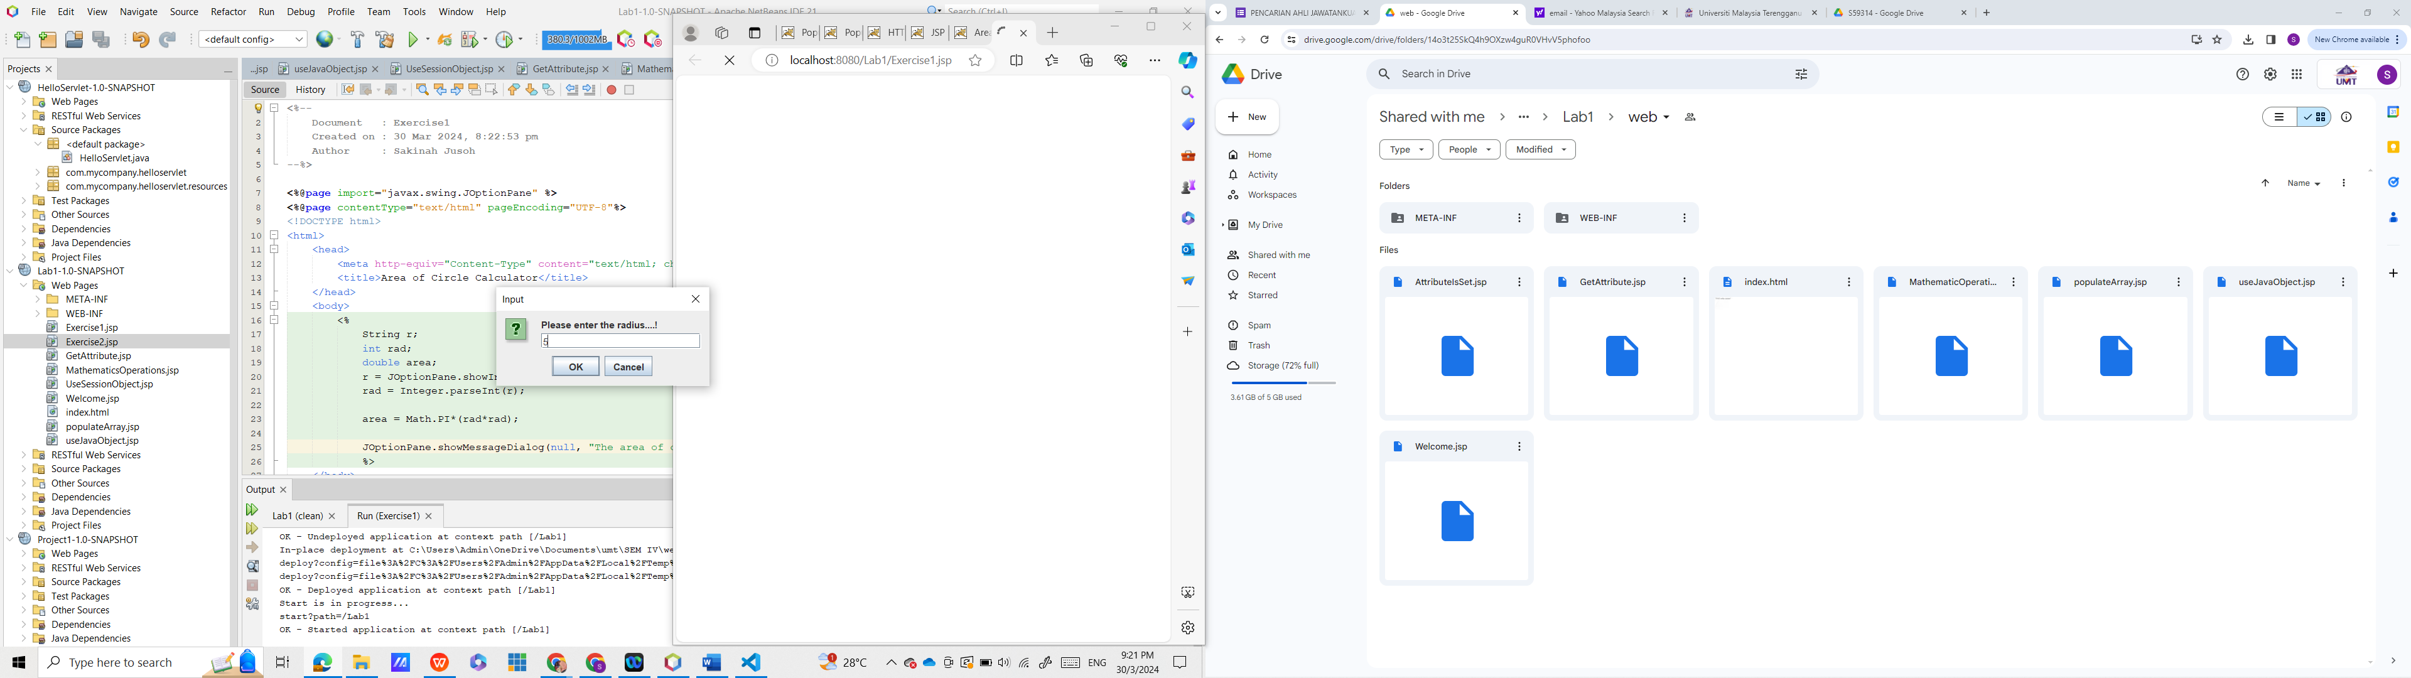

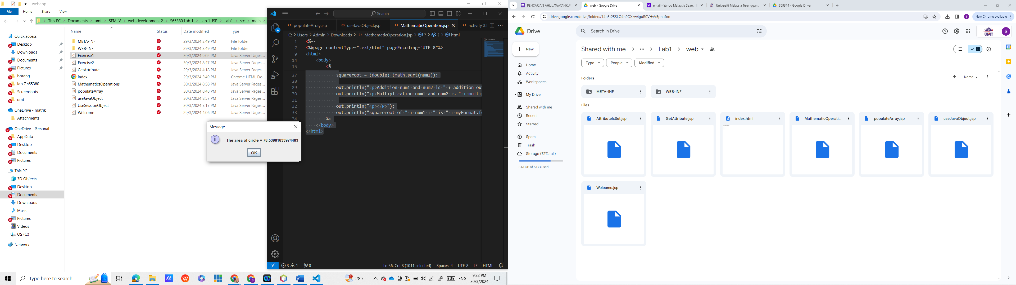

**Exercise 2**

**Source code**

